Anthony Sevarino

EET 2141

Fall ‘24

**Lab 6 Bipolar Junction Transistors – Collector and Base Biasing**

**Introduction:**

The objective of this lab is to analyze bipolar junction transistors, specifically the interactions and behaviors of measurable data such as voltage and current across collectors and bases, and their biasing within various circuits. A BJT contains three ‘doped’ sections, the base, the collector, and the emitter. These BJTs are designed to take a certain amount of current through its base and produce a large resulting collector current. Thus, this lab will focus on the characteristics of base biased circuits. To ‘bias’ a circuit in this circumstance means to match the type of transistor to the direction of current flow, thus creating an amplifier of the current source.

**Bench Parts and Equipment List:**

|  |  |  |  |
| --- | --- | --- | --- |
| ***Components*** |  |  |  |
| • | 100kΩ, 1kΩ Resistors | • | BJT Transistors (2N3904) |
| •  ***Equipment*** | Numerous Connector Wires |  |  |
| • | Programmable DMM | • | ELENCO Trainer Board |
| • | Windows Machine w/  Multisim |

**Discussion:**

# Part 1 – The Simulation

The first step of this lab is to construct the given circuits in Multisim, the following is the provided image for each given circuit purposed toward the study of this lab

(See below)

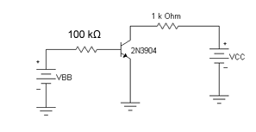

Figure - Circuit 1 Diagram Provided by Lab Manual

Figure - Circuit 2 Diagram Provided by Lab Manual

The constructed Multisim circuits are as follows:

Figure 4 - Circuit 2 Constructed in Multisim



Figure - Circuit 1 Constructed in Multisim

Note that attached are both digital multimeters, as well as Multisim analysis probes used for obtaining simulation measurements. Notice that all three of the BJTs are in the same orientation, with the emitter carrying the flow of current out of the bottom.

Circuit 1 is a simple two switch, BJT series circuit with a resistor in between each switch. Circuit 2 differs from circuit 1 in the sense that there is a resistor added to the bottom of the circuit in between the second BJT and the ground. Finally, circuit 3 is the clear outlier in the sense that the BJTs are connected in parallel to one another rather than in series as seen in the previous two circuits.

Circuit 1 is a simple, single BJT circuit with two voltage sources, one connected in series to the resistor to the collector of the BJT (labelled as *VCC*), and one connected in series to the resistor to the base of the BJT (labelled as *VBB*). Circuit 2 is also a simple single BJT transistor circuit, however this circuit utilizes only one DC voltage source but a large value resistor in parallel connected to the base of the transistor, and a relatively smaller resistor connected to the collector.

The voltmeter used to conduct testing was later changed to a multimeter following the capture of these images, in other words, the voltage probes appearing in the images was no longer used.

Below are the recorded measurements for the simulation data:

**Table 1 – Simulation Data for Circuit 1**

|  |  |  |  |  |  |  |
| --- | --- | --- | --- | --- | --- | --- |
| **Collector to Emitter Voltage**  **(VCE)** | **Portion A**  **Base Current = 30µA** | | | **Portion B**  **Base Current = 60µA** | | |
|  | **Vcc**  **(V)** | **Voltage Across Rc**  **(V)** | **Current Through Rc**  **(A)** | **Vcv**  **(V)** | **Voltage Across Rc**  **(V)** | **Current Through Rc**  **(A)** |
| 3V | 3.045 | 3 | 44.4µ | 3.11 | 3 | 114 µ |
| 5V | 5.045 | 5 | 45.5 µ | 5.12 | 5 | 117 µ |
| 7V | 7.045 | 7 | 46.7 µ |  |  |  |
| 9V | 9 | 9 |  |  |  |  |

**Table 2 – Simulation Data for Circuit 2**

|  |  |  |  |  |
| --- | --- | --- | --- | --- |
| **Collector-to-Emitter Voltage**  **(VCE) (V)** | **Voltage across RC**  **(V)** | **Current Through RC**  **(A)** | **Voltage across RB**  **(V)** | **Current Through RB**  **(A)** |
| 4.79 | 5.27 | 5.21m | 4.08 | 3.15µ |

# Part 2 – The Bench

The circuit is now constructed on the bench, below are captures of each circuit constructed

Note that in the second constructed bench circuit, an approximately 130kΩ resistor is required, however this value resistor is not present in the semiconductors lab kit, therefore the variable resistor present on the ELENCO trainer must be set to 30kΩ and connected in series to a 100kΩ resistor which is included in the semiconductors lab kit.

(See below)

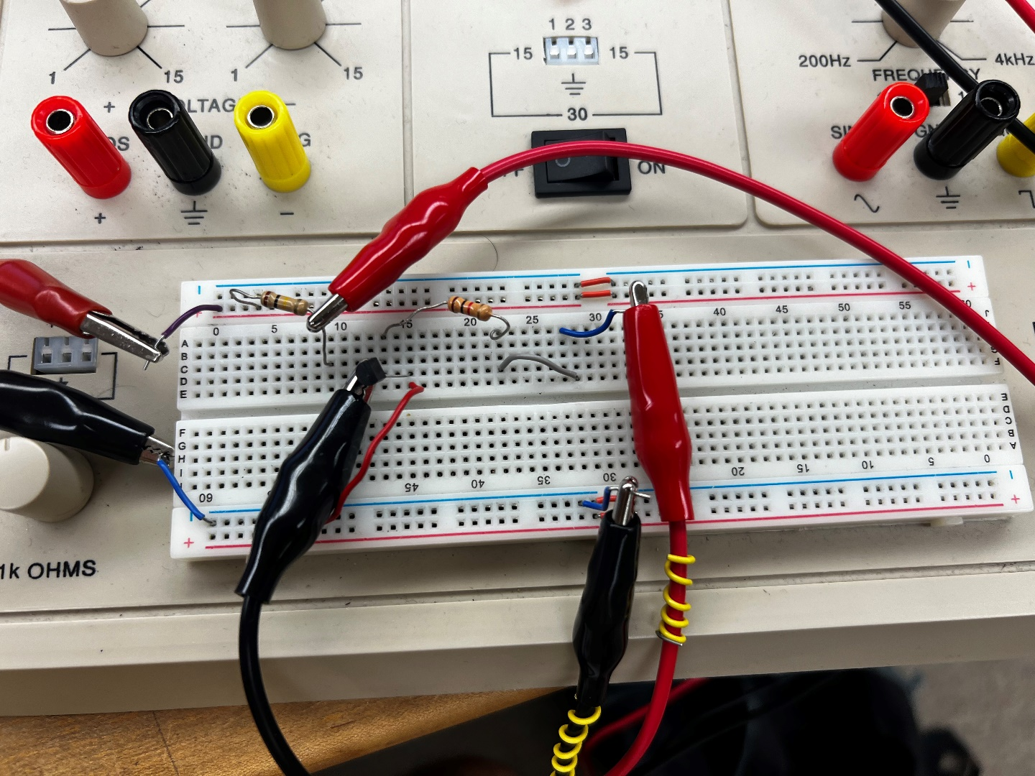

Figure 5 - Circuit 1 Constructed on the bench

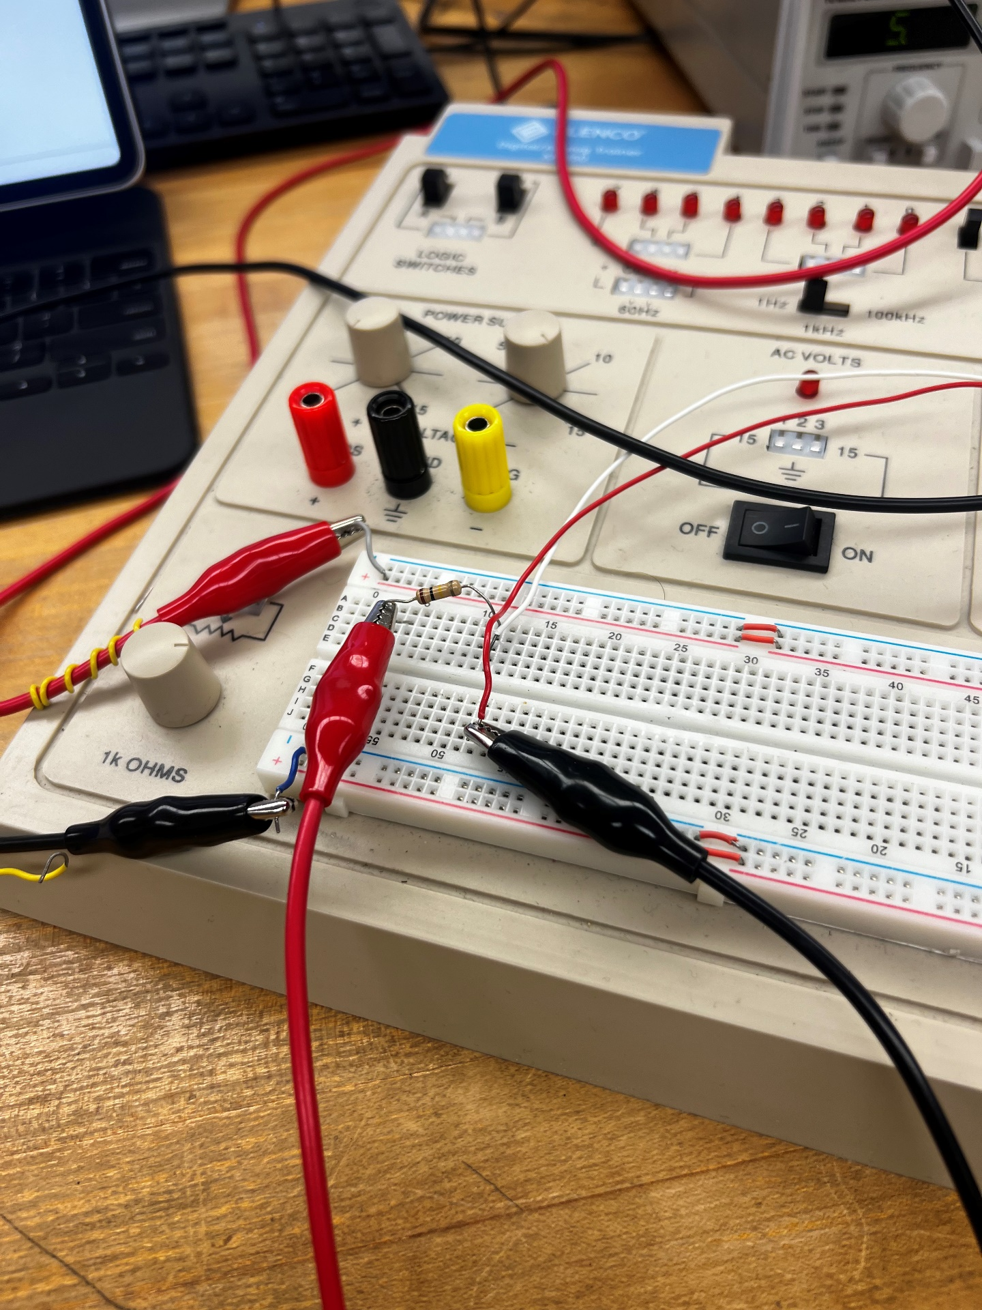

Figure 6 - Manipulation of ELENCO Trainer Variable Resistor in Series with 100kΩ Resistor

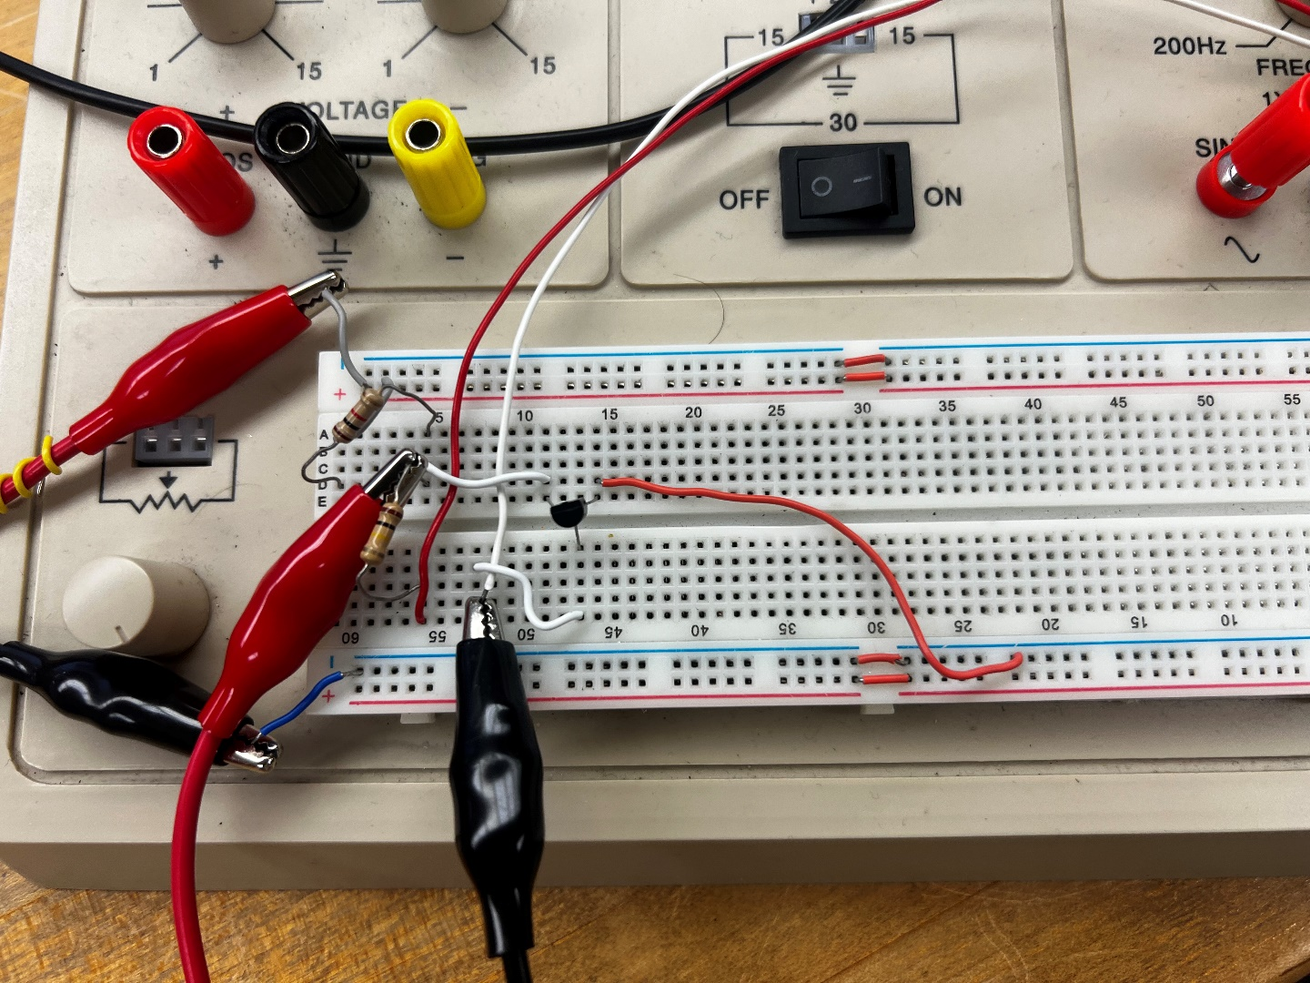

Figure 7 - Circuit 2 Constructed on the Bench

Below is an analysis of the data obtained on the bench:

**Table 3 – Bench Data Circuit 1**

|  |  |  |  |  |  |  |
| --- | --- | --- | --- | --- | --- | --- |
| **Collector to Emitter Voltage**  **(VCE)** | **Portion A**  **Base Current = 30µA** | | | **Portion B**  **Base Current = 60µA** | | |
|  | **Vcc**  **(V)** | **Voltage Across Rc**  **(V)** | **Current Through Rc**  **(A)** | **Vcv**  **(V)** | **Voltage Across Rc**  **(V)** | **Current Through Rc**  **(A)** |
| 3V | 3.2 | 3.11 | 31.33µ | 2.98 | 3.22 | 98 µ |
| 5V | 5.31 | 5.14 | 43.41 µ | 4.77 | 5.11 | 101 µ |
| 7V | 7.01 | 6.89 | 51.87 µ |  |  |  |
| 9V | 8.79 | 9.75 |  |  |  |  |

**Table 4 – Bench Data for Circuit 2**

|  |  |  |  |  |
| --- | --- | --- | --- | --- |
| **Collector-to-Emitter Voltage**  **(VCE) (V)** | **Voltage across RC**  **(V)** | **Current Through RC**  **(A)** | **Voltage across RB**  **(V)** | **Current Through RB**  **(A)** |
| 4.25 | 5.61 | 5.56m | 4.39 | 27.6µ |

# Part 3 – The Comparison

Thus, it would appear that the bench measurements and simulation data both follow the same trend, and are relatively close in terms of values. Below is a graphical comparison of the two datasets:

Figure 8 - Data Comparison of Circuit 2 Measurements

Figure 9 - Data Comparison of Circuit 1 Measurements

Finally, for certification purposes, below the instructor sign-off can be found. As a reminder, this signature is obtained by either the course instructor or a certified lab assistant to ensure proper results are being obtained.

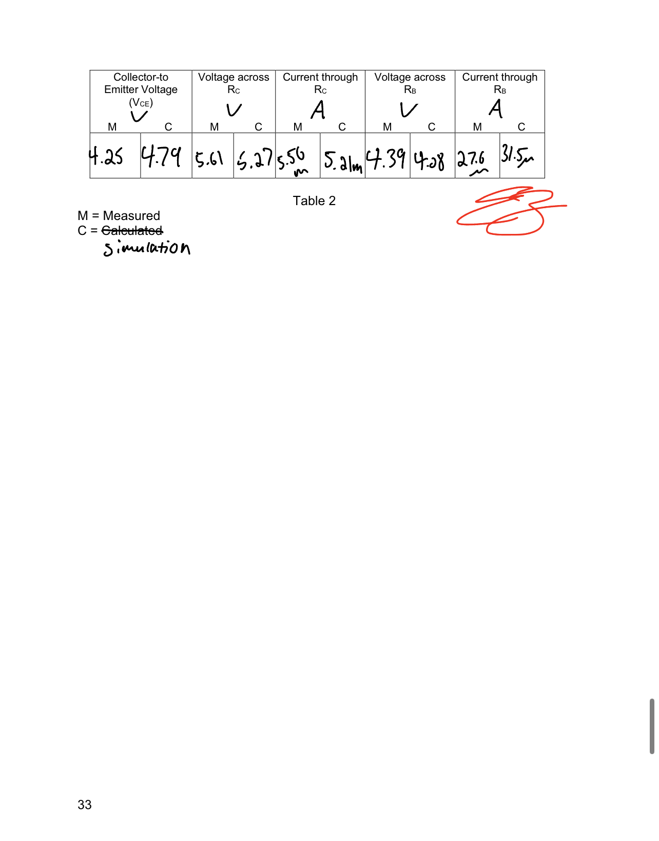

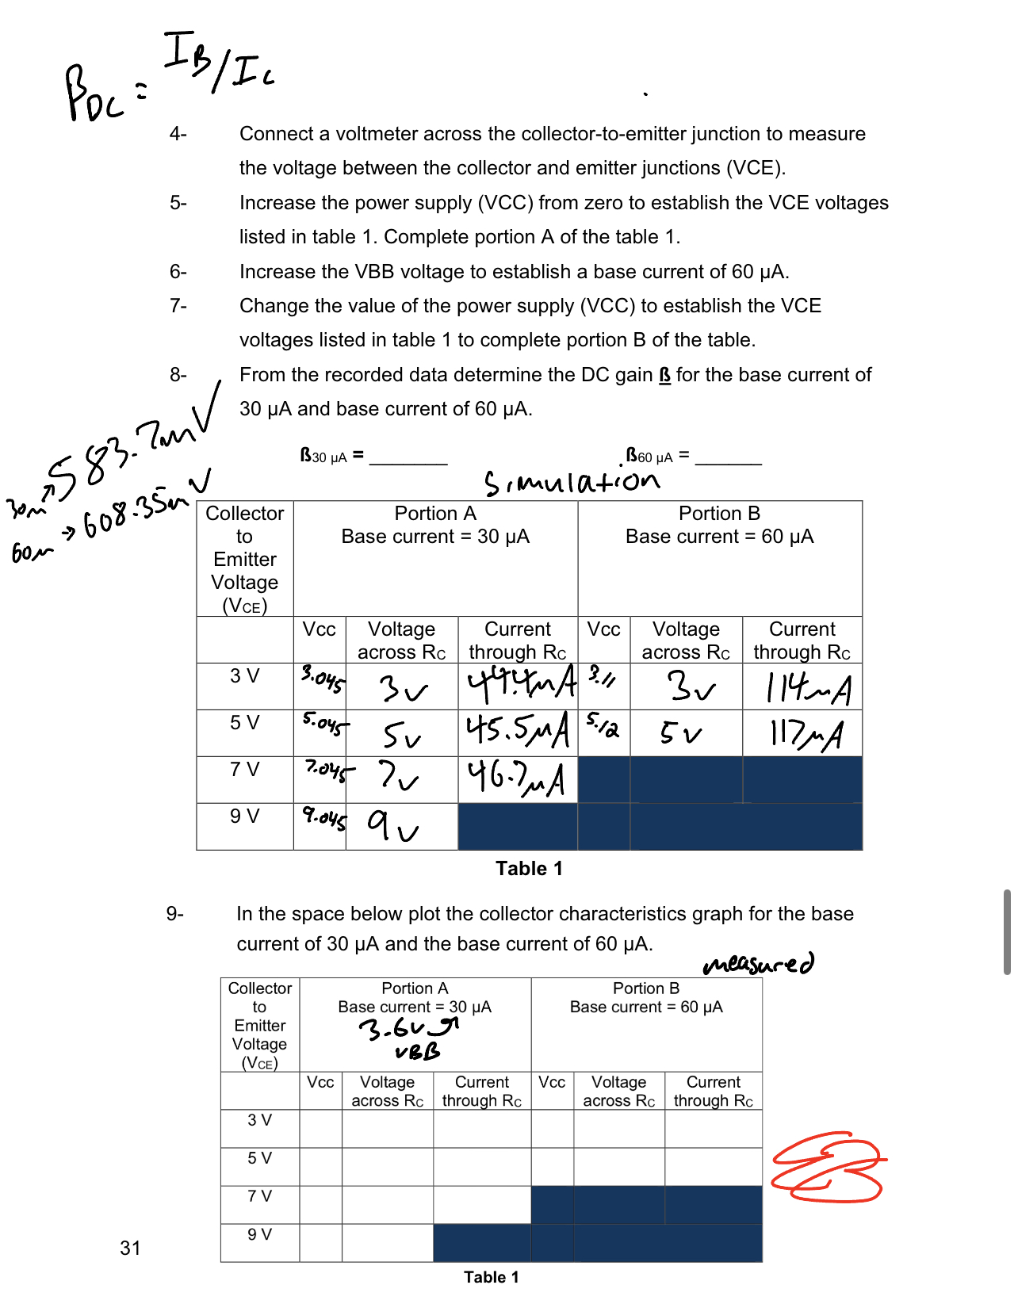

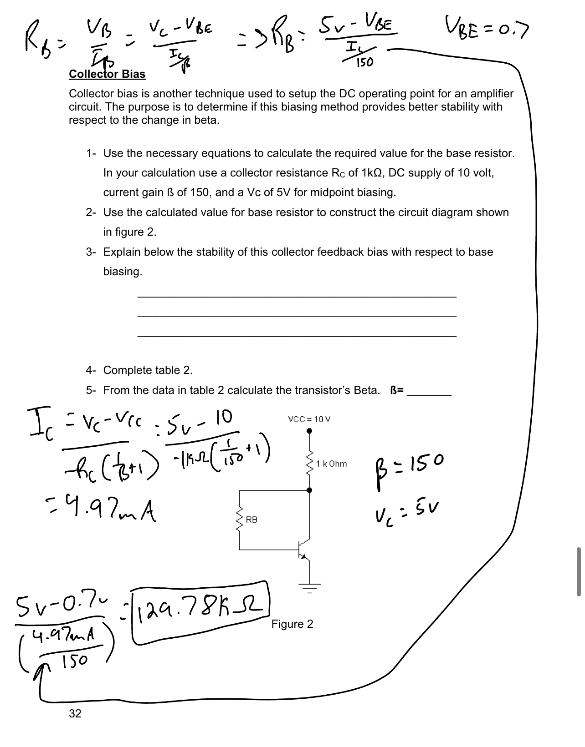

**Conclusion:**

The objective of this lab is to obtain an understanding and visualization of the behavior and purposes of BJTs in various circuits. The particular behavior being analyzed is that of the relationship between measurable data in the collectors, bases, and emitters of these transistors. This lab demonstrates how to ‘bias’ a bipolar junction transistor circuit in order to create a functioning amplifier. Two different circuits are analyzed, one with two sources (one for the base and one for the collector), as well as one with a single source connected to both the base and the collector through series and parallel connections with resistors. If this lab were to be conducted again, it would be pertinent to include additional circuits that offer differing biases, or current flow directions, with different types of transistors, namely common collector amplifiers and related circuits. That being said, this lab was conducted successfully based on the comparison of the data between simulation and bench measurements, as they not only follow the same trends, but also match values very closely.